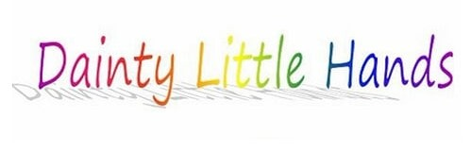

Meals and Mealtimes: Quick Facts
- In England, the provision of meals is covered under Section 3: The Safeguarding and Welfare Requirements of the revised Early Years Foundation Stage (EYFS) statutory framework.
- Babies should drink either breast or formula milk until they are 12 months old at least.
- Staff should discourage unacceptable behaviour during meals (such as standing at the table or throwing food) by removing the child from the table to wait until later to eat.
- For lunches for children in early years services there should be a balance of ingredients from each of the four main food groups.
- Snacks should be provided as pre-school children have small stomachs and will not settle during large meals.
- Drinking water should be provided throughout the day.
- Different cultures have specific dietary requirements. These should be respected and supported at mealtimes.
- Where food is provided by parents the early years service will need to ensure that the food is suitable.
- Children under three years are particularly vulnerable to choking caused by a foreign object in their airways.

