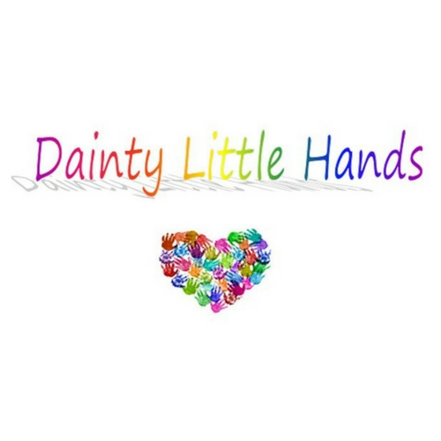

Staff Behaviour Policy

Dainty Little Hands Ltd. Out of School Clubs expects all members of staff to follow our Staff Behaviour Policy, which sets clear guidance on the standards of behaviour required from our staff and volunteers. The guidance aims to encourage staff to meet the highest possible standards of conduct. Club staff are in a position of trust and influence as role models for the children in their care, and as such must demonstrate behaviour that sets a good example to all users of the setting.

Club staff also have a responsibility to maintain their reputation and the reputation of the Club, both during and outside of working hours.
Behaviour
Our staff team are ambassadors for all Dainty Little Hands Ltd Out of School Clubs, and we expect them to conduct themselves professionally at all times for the avoidance of doubt, this includes all Social Media conduct. Staff should treat anyone attending the Club (children, parents/carers, and visitors) courteously and with respect.
We expect staff to value all the children as individuals and to comply with the Club’s Equality, Equity, Diversity and Inclusion Policy at all times.
Swearing and abusive behaviour are not tolerated from anyone at the Club. If any member of staff exhibits such behaviour they will be subject to the Club’s disciplinary procedures.
Dress code
Whilst working at Dainty Little Hands Ltd Out of School Clubs staff will need to help set up and pack away the setting, prepare food, facilitate craft activities and engage in physical activities with the children. The clothing and footwear worn should be chosen accordingly, taking into account comfort, health and safety, and practicality. Revealing or excessively tight clothing is not acceptable.
Whilst on duty all staff should wear the approved Club sweatshirt / T shirt / colours / name badge at all times.
Clothes should be freshly washed daily (for further information, see Infection Control Policy).

Confidentiality and social media
Staff must not pass on any information about children attending the Club, or their parents and families, to third parties without their permission. The only exception to this rule is information sharing with specific external agencies if there is a safeguarding issue. (‘Third parties’ includes other parents, friends, other children at the Club, the press, etc.)
Posting any material relating to the Club, the Host School, or any Stakeholder, for the avoidance of doubt, including Staff members, parents and children, or its users on social media sites (unless expressly permitted by the Club Manager/Support Managers) is forbidden. Any staff who breach this rule will face disciplinary action.
See our Privacy Notice, Social Media policy, Child Protection and Safeguarding policy and Staff Disciplinary policy for more details.
Use of mobile phones and cameras
Staff personal mobile phones must be locked away during working hours.
If a member of staff needs to make an urgent personal call, they can use the Club phone only or make a personal call from their mobile outside of the Club room.
If a member of staff has a family emergency or similar and needs to keep their mobile phone to hand, they must obtain prior permission from Jayne Dainty.
Staff may only use the club camera to take photographs of children at the Club, except with the express permission of Jayne Dainty.
Staff must never use their personal mobile phones or cameras to take photographs at the Club during working hours. Doing so will be considered gross misconduct and may result in instant dismissal.
See our Mobile Phone policy, Child Protection and Safeguarding policy and Staff Disciplinary policy for more details.
Smoking, Vaping, alcohol and drugs
Staff are not permitted to smoke or vape anywhere on the Club premises, including the outside play areas.
Staff are not permitted to bring alcohol or illegal drugs onto the Club premises. If a member of staff arrives at work under the influence of alcohol or drugs they will be asked to leave immediately and disciplinary action will be taken.
If a member of staff is taking prescription drugs which might affect their ability to function effectively, they must inform the Club Manager immediately. If the Club Manager is taking prescription drugs which might affect their ability to function effectively, they must inform the Support Managers immediately.
Any prescribed medication needed by a staff member whilst at the Club, must be stored safely in the locked cabinet out of reach and sight of the children attending the Club. The staff member will be supported at an appropriate time and place to administer their medication. A risk assessment will be completed.
See our Smoking, Alcohol and Drugs policy for more details.

Gross misconduct
Staff will be dismissed without notice if they are found to have committed an act of gross misconduct. Examples of gross misconduct include, but are not restricted to:
- Child abuse
- Failing to comply with health and safety requirements
- Physical violence
- Ignoring a reasonable, direct instruction given by the Club Manager, Support Managers or Managing Director.
- Persistent bullying, sexual or racial harassment
- Being unfit for work through alcohol or illegal drug use
- Theft, fraud or falsification of documents
- Being disqualified under the terms of the Statutory Framework for the Early Years Foundation Stage (Section 75 of the Childcare Act 2006) or the Children’s Act 1989.
The Support Managers will investigate the alleged incident thoroughly before any decision to dismiss is made. For full details see our Staff Disciplinary policy.

This policy was adopted by: Dainty Little Hands Ltd | Date: 04/08/2021
To be reviewed: 03/08/2022 | Signed: Jayne Dainty

Written in accordance with the Statutory Framework for the Early Years Foundation Stage (2017): Safeguarding and Welfare Requirements: Child Protection [3.4-3.8], Suitable people [3.11, 3.13, 3.19] and Disqualification [3.14-3.16], Safety and suitability of premises, environment and equipment [3.56], Information and records [3.70]

