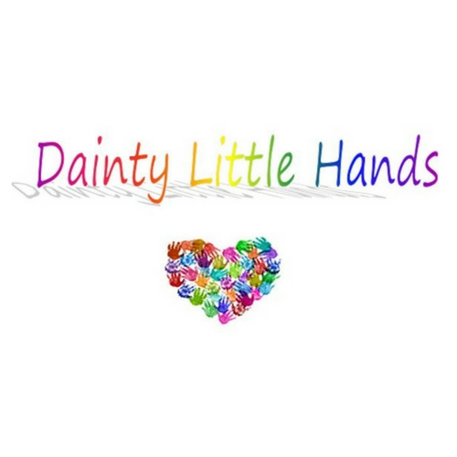

Social Media Policy

Dainty Little Hands Ltd Out of School Clubs recognises that many staff enjoy networking with friends and family via social media. However, we have to balance this against our duty to maintain the confidentiality of children and parents attending our Club, as well as ensuring that our good reputation, and the good reputation of the Host School, is upheld. Staff must remember that they are ambassadors for our Club both within and outside of working hours and are expected to conduct themselves accordingly when using social media sites.

This policy covers (but is not limited to) social media platforms such as:
- Twitter
- Facebook
- YouTube
- Tumblr
- TikTok
- Snapchat
- Instagram
- Pinterest
- LinkedIn
- Personal blogs and websites
- Comments posted on third party blogs or websites
- Online forums
Social media rules
When using social media sites, staff must not:
- Post anything that could damage our Club’s reputation.
- Post anything that could offend other members of staff, parents or children using our Club.
- Publish any photographs or materials that could identify the children or our Club.
- Post anything that could offend other members of staff, parents or children, related to the Host School.
- Accept invitations from parents to connect via social media (e.g., friend requests on Facebook) unless they already know the parent in a private capacity.
- Discuss with parents any issues relating to their child or our Club. Instead invite the parent to raise the issue when they are next at the Club, or to contact the Club Manager or Support Manager(s) if the matter is more urgent.
Any member of staff who posts content or comments that breach confidentiality or which could harm the reputation of our Club or other staff members, or who publishes photographs of the setting or children, will face disciplinary action in line with our Staff Disciplinary policy.

General cautions for using social media
When using social media in any context it is wise to bear in mind the following points:
- No information published via the internet is ever totally secure; if you don’t want information to become public, do not post it online.
- Once an image or information is in the public domain, it is potentially there forever – Google never forgets!
Related policies
See also: Mobile Phone policy, Staff Disciplinary policy, Child Protection and Safeguarding policy.

This policy was adopted by: Dainty Little Hands Ltd | Date: 04/08/2021
To be reviewed: 03/08/2022 | Signed: Jayne Dainty

