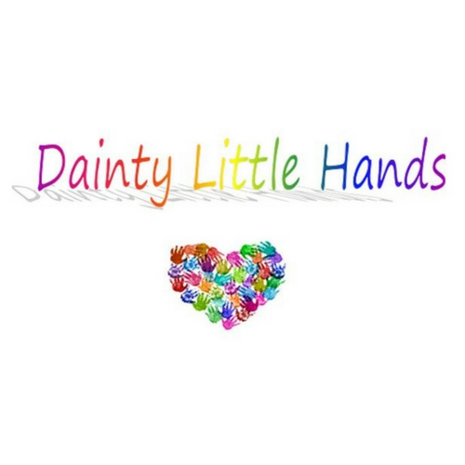

Manual Handling Policy
Incorrect manual handling procedures is one of the major causes of absence through injury in the workplace. At Dainty Little Hands Ltd Out of School Clubs we work with our staff, provide training, and undertake risk assessments in order to eliminate hazardous manual handling activities as far as possible.
This policy is written with reference to the Health and Safety at Work Act 1974, which places a duty on employers “to ensure so far as is reasonably practicable, the health, safety and welfare of its employees”, and to the Manual Handling Operations Regulations 1992 (as amended).
Procedure
In order to limit the risk of injury from manual handling operations, Dainty Little Hands Ltd Out of School Clubs will:
- Eliminate hazardous manual handling activities, as far as is reasonably practicable
- Assess the risks associated with any manual handling activities that cannot be avoided.
The purpose of the risk assessment is to reduce the risk of injury to the lowest possible levels, and should consider:
- The task
- The load
- The individual undertaking the task
- The working environment.
The main manual handling hazard at Dainty Little Hands Ltd Out of School Clubs is likely to be the setting-up and clearing-away of equipment. This is unavoidable, but staff should carry out the operation with reference to the guidance given in the manual handling training that we provide. It may be necessary to seek the assistance of an additional member of staff in order to minimise the risk of injury, for example when carrying tables and other heavy or bulky items.
Employee’s duties
It is the responsibility of all staff at Dainty Little Hands Ltd Out of School Clubs to:
- Comply with any instructions and training provided in safe manual handling techniques
- Not put their own health and safety or that of others at risk by carrying out unsafe manual handling activities
- Report to the Club Manager and Support Manager(s) any problems which may affect their ability to undertake manual handling activities, including physical and medical conditions (e.g. pregnancy, back problems).

In summary
Avoid Whenever possible, avoid manual handling situations.
Assess If avoidance is not possible, make a proper assessment of the hazard and risks.
Reduce Reduce the risk of injury by defining and implementing a safe system of work.
Review Review your systems regularly, to monitor the overall effectiveness of the policy.

This policy was adopted by: Dainty Little Hands Out of School Clubs | Date: 04/08/2021
To be reviewed: 03/08/2022 | Signed JAYNE DAINTY
Written in accordance with the Statutory Framework for the Early Years Foundation Stage (2017): Safeguarding and Welfare Requirements: Staff Qualifications, training, support and skills [3.20]

