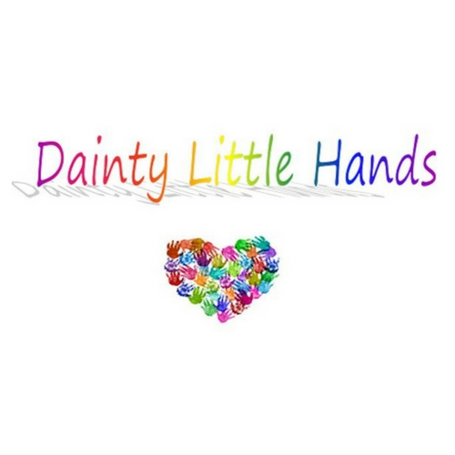

Food Safety Policy
Dainty Little Hands Ltd Out of School Clubs is committed to ensuring that safe and healthy practises around the storage, preparation and service of food are followed at all times. Staff involved in food handling and preparation have to meet high standards of personal hygiene. Any member of staff showing signs of infection or ill health will not be permitted to handle food.
Dainty Little Hands Ltd Out of School Clubs follows the guidelines set out in ‘Safer Food, Better Business’ (FSA) and is registered as a food business with our local authority. We are regularly inspected by Environmental Health to ensure that health and hygiene standards are being met.
All staff involved in food handling have received food handling and hygiene training. When preparing food, staff follow the requirements of current food hygiene legislation, including:
- Always washing hands with anti-bacterial soap and hot water for at least 20 seconds before and after handling food and using the toilet;
- Using clean, disposable cloths;
- Using the correct colour coded chopping boards (e.g. red for raw meat);
- Not being involved in food preparation if they are unwell;
- Making sure all fruit and vegetables are washed before being served;
- Removing jewellery, especially rings, watches and bracelets, before preparing food;
- Covering spots or sores on the hands and arms with a waterproof dressing;
- Keeping fingernails short, clean, and free from varnish.

Food storage
All foods are stored according to safe food handling practices and at a correct temperature, to prevent the growth of food poisoning organisms and to ensure that food quality is maintained.
Fridge temperatures are checked and recorded on a daily basis as part of our daily environment checks. If it is noted that there are temperature fluctuations that are not explained by simple user error (e.g. failure to close the fridge properly), a new fridge will be purchased.

Cleaning (Amended for COVID-19)
- The fridge is cleaned thoroughly, with warm, soapy water, on a DAILY basis.
- Food is checked for freshness – anything past the use by date will be disposed of.
- Freezers are defrosted and cleaned once PER WEEK.
- All food preparation surfaces are wiped clean after use with CLEANING PRODUCT SUPPLIED BY THE Host school and disposable cloths.
- All chopping boards are cleaned after use with CLEANING PRODUCT SUPPLIED BY THE Host school and then thoroughly rinsed.
- Appropriate controls are implemented to reduce the risk of cross contamination.

This policy was adopted by: Dainty Little Hands | Date: 02/08/2021
To be reviewed: 01/08/2022 | Signed: Jayne Dainty
Written in accordance with the Statutory Framework for the Early Years Foundation Stage (2017):
Safeguarding and Welfare Requirements: Food and drink [3.48].

