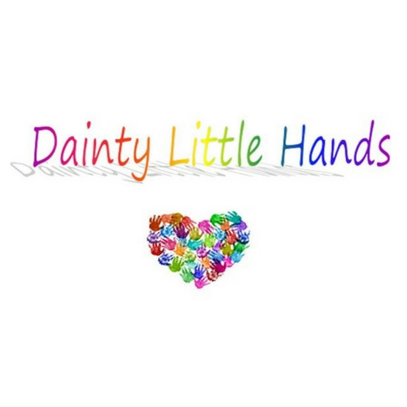

Equality, Equity, Diversity, and Inclusion Policy

Policy Statement
Dainty Little Hands Ltd Out of School Clubs is committed to providing a holistic approach to meet all needs of all children and staff, while promoting understanding of the principles and practices of equality and justice. The provision encourages equal opportunities and operates an equal access policy.
All children, irrespective of their age, heritage, skin pigmentation, family structure and social, cultural and religious backgrounds, gender or sexual orientation and all children with disabilities and additional needs, are provided with equal access to all care and play facilities provided by Dainty Little Hands Ltd.
The provision respects and celebrates cultural and physical diversity and acknowledges its responsibility to promote positive images and role models to the children in its care. Activity programs will reflect the diverse nature of our society in an environment where stereotyping is not an option.

Staff Duties
Staff will be expected to create an atmosphere that allows children to feel valued and enable them to develop a high self-esteem. It is the responsibility of all members of staff to ensure that the statements in this policy are complied with. Members of staff who are found to be in breach of this policy will be subject to disciplinary action.
Any signs of direct or indirect discrimination resulting in one person being treated less favourably than another must be challenged. The provision expects that unacceptable conduct of an anti-discriminatory nature, from staff or any adult, which has been observed by another member of staff, would be reported.

Activities and Play Materials
The activities and play materials in the provision help the children to broaden their knowledge and understanding of people and their differences in our society and the world at large. For example, as well as celebrating Christian festivals, the provision bases activities on religious and cultural celebrations from across the globe, and the children play with dolls and other toys which reflect diverse characteristics which may be different from their own. All children in this provision are given the opportunity to play with all the toys (subject to health and safety with children under three years of age). All Club provisions managed by Dainty Little Hands Ltd. Out of School Clubs highlight the importance of play opportunities by including and having knowledge of the 16 types of play. The 16 types of play are used to enrich play activities and opportunities in Club, to ensure all aspects of play are covered and can be accessed by the children in our care.

Adaptations
All children in this provision are provided with the opportunity to reach their full potential. Sometimes this may involve staff adapting an activity to suit the individual ability or stage of development of a child, providing additional or different resources or by providing additional staff support and attention.
Signed: | ________Jayne Dainty_____________________
Date: | ________02/08/2021_____________________
Policy review date: | __________01/08/2022___________________

