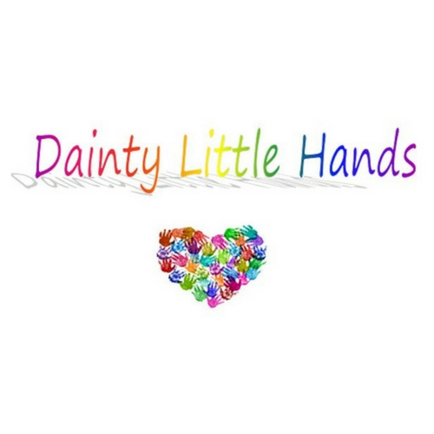

Behaviour Management Policy

Dainty Little Hands Ltd. Out of School Clubs uses effective behaviour management strategies to promote the welfare and enjoyment of children attending the Club. Working in partnership with parents, we aim to manage behaviour using clear, consistent, and positive strategies. The Club rules are clearly displayed at every session and are discussed regularly.

Whilst at Before, After School and Holiday Club we expect children to:
- Use socially acceptable behaviour
- Comply with the Club rules, which are compiled by the children attending the club
- Respect one another, accepting differences of race, gender, ability, age, and religion
- Develop their independence by maintaining self-discipline
- Choose and participate in a variety of activities
- Ask for help if needed
- Enjoy their time at the Club
- Use the behaviour flow chart to engage individuals and a group of children

Encouraging positive behaviour
At Dainty Little Hands Before, After School and Holiday Club positive behaviour is encouraged by:
- Use the club slogan ‘What did YOU do well today?’
- Children contributing in making the club rules
- Staff acting as positive role models
- Praising appropriate behaviour
- Sticker rewards
- Informing parents about individual achievements
- Offering a variety of play opportunities to meet the needs of children attending the Club, with the 16 play types in mind to ensure all activities are enriched and engaging
- If necessary, using the host school’s own behaviour reward system
It is inevitable that as children develop and learn, there are times when they need support and guidance to understand that their behaviour is not acceptable. Staff at the Club will try to determine the cause or triggers of the inappropriate behaviour to prevent the situation from recurring.

Dealing with inappropriate behaviour
Challenging behaviour will be addressed in a calm, firm and positive manner.
- If the behaviour continues staff should use distraction techniques to promote positive play and engagement always.
- Staff will discuss why the behaviour displayed is deemed inappropriate.
- Staff will give the child an opportunity to explain their behaviour, to help prevent a
recurrence.
- Staff will encourage and facilitate mediation between children to try to resolve conflicts through discussion and negotiation.
- If the inappropriate behaviour appears to be because of boredom, staff will consult with the child to find activities that more fully engage them.
- Staff will consult with parents to formulate clear strategies for dealing with persistent
inappropriate behaviour.
- We will not threaten any punishment that could adversely affect a child’s well-being (e.g., withdrawal of food or drink).

If after consultation with parents and the implementation of behaviour management strategies, a child continues to display inappropriate behaviour, the Club may discuss the option of a one-to-one support for the child.
In certain circumstances, the Club may discuss with school and relevant outside organisations about the behaviour. The reasons and processes involved, will be clearly explained to the parents and child.

COVID-19
We understand that negative experiences and distressing life events, such as the current circumstances, can affect the mental health of pupils and their parents.
The DfE’s guidance on mental health and behaviour in schools sets out how mental health issues can bring about changes in a young person’s behaviour or emotional state which can be displayed in a range of different ways, and that can be an indication of an underlying problem. Support for pupils in the current circumstances can include existing provision in school (although this may be delivered in different ways, for example over the phone) or from specialist staff or support services. You can read the guidance on mental health and behaviour in schools here.
We are committed to supporting our Host School in delivering any extra support deemed necessary and will liaise with the Head Teacher if we have any concerns regarding new behaviour concerns regarding an individual pupil.
For wider information about context please try here:
Mental health related to the Covid-19
Mentally Healthy Schools

Corporal punishment and Exclusion
Corporal punishment, exclusion or the threat of corporal punishment or exclusion will never be used at the Club.
We will take all reasonable steps to ensure that no child who attends our Club receives corporal punishment from any person who cares for or is in regular contact with the child, or from any other person in our setting.

Dainty Little Hands

Behaviour Flow Chart

Ask Children To Follow An Instruction

Raise Your Hands In The Air & Wiggle Your Fingers To Attract Children’s Attention
Say everybody FREEEEEZE – the children should respond with ‘Macaroni Cheese!’
(Blow Lightly On Your Whistle If Required)

Play ‘Simon Says’ To Engage Them

Give Instruction and Explanation

Remain Calm, Positive & Engaging At All Times

Discussing behaviour flow chart
Speak with their parents/carers to discuss the behaviour

Speak to the School to understand if the behaviour(s) has been observed in the School setting and what provisions are in place

Complete an appropriate action plan to support the child with their behaviour

Next review date: _________29/07/2022___________
Signed: _________Jayne Dainty__________
Date: _________30/07/2021___________

Written in accordance with the Statutory Framework for the Early Years Foundation Stage (2014):
Safeguarding and Welfare Requirements: Managing behaviour [3.52-3.53].

