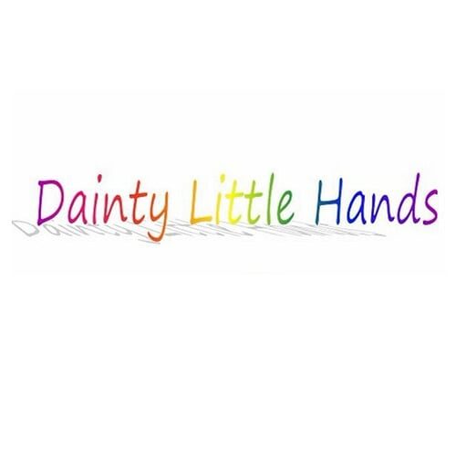  Week Commencing | Topic | Activity Idea’s
4th January 2021 | What I have done in the holiday’s, World Braille Day | Circle times, drawings. World Braille Day 4th.
11th January 2021 | Martin Luther King Day, Houseplant Week | Martin Luther King Day 15th. How to care for different plants
18th January 2021 | Storytelling, World Religion Day | Bring in favorite book, poster of book. World Religion Day 17th.
25th January 2021 | Birdwatch 2021 | Draw a bird, bird feeders/food, go outside
1st February 2021 | Children’s Mental Health Week | Place2Be website, express yourself
8th February 2021 | Valentines, Chinese New Year | What I like about me, letters, cards, story of the animals, food tasting
15th February 2021 | Half Term
22nd February 2021 | Pancake Day, Lent | What did you have for Pancake Day? Food tasting, did you give up anything for Lent?
1st March 2021 | World Book Day, St David’s Day | St David’s Day 1st World book day 4th, why do we have St David’s day? Finding information
8th March 2021 | Mother’s Day, Language Week | Mother’s Day 14th card marking, present making. Learn different words from around the world and what they mean
15th March 2021 | St Patrick’s Day, Spring | St Patrick’s Day 17th Grow plants, the season’s, weather. Spring starts 20th March
22nd March 2021 | World Theatre Day | World Theatre Day 27^{th.} Make your own play. Role play.
29th March 2021 | Easter | Different beliefs, Pagan, Christian, Jewish, Catholic, cards, easter egg hunts
5th April – 16th April 2021 | Easter Holidays
19th April 2021 | World Heritage Day | World Heritage Day 18th. Family trees
26th April 2021 | Passover Jewish | Talk about what it is
3rd May 2021 | Ramadan | Ramadan from 12th April – 11th May. What is it, activity sheets
10th May 2021 | International Nurses Day | International Nurses Day 12th. Why are we thankful for Nurses?
17th May 2021 | Buddha’s Birthday | Buddha’s Birthday 19^{th.} Meditation, talk about Birthdays
24th May 2021 | Green Week | Activity sheets, how to reduce carbon footprint, junk modelling
31st May – 4th June 2021 | Half Term
7th June 2021 | Hopes and Dreams | What I want to be when older
14th June 2021 | Father’s Day | Cards, who I love
21st June 20121 | Space | Make rockets, make dens
28th June 2021 | Superhero | Make capes, what powers would you have,
5th July 2021 | Fitness week | Obstacle course, food,
12th July 2021 | Sumer holiday plans | List of ideas for free,
19th July – 30th August 2021 | Summer Holidays
30th August 2021 | Animal week | Animals at home, masks
6th September 2021 | All about me | Self-portraits, poem writing, family tree,
13th September 2021 | Nature week | Bug hunt, art Rock, bird feeder,
20th September 2021 | Autumn | The seasons, weather, collect items,
27th September 2021 | Harvest festival | Bring in a tin of food and will take to local food banks
4th October 2021 | Black History Month | Black History Month throughout October. What is it, worksheets
11th October 2021 | Multi-cultural | Learning about different cultural
18th October 2021 | Halloween | Halloween 31st
25th October 2021 | Half Term
1st November 2021 | Bonfire, Diwali | Diwali 4th November. Picture making, activity sheets,
8th November 2021 | Anti-bullying week, Remembrance Sunday | Anti-Bullying week 11th November – 15th November. Talk about bullying, who can help, talk about war
15th November 2021 | Nursery Rhyme week, Road Safety Week | 15th – 19^{th.} Favorite songs, make up own rhymes. Road Safety Week 16th-21st.
22nd November 2021 | Thanksgiving | Thanksgiving 25th. Circle time, stories,
29th November 2021 | Winter, St Andrews Day, International Day of Persons with Disabilities | The season’s, weather, picture’s, circle time, stories. St Andrews Day 30th. International Day of Persons with Disabilities 3rd.
6th December 2021 | Caring for others | Shoe boxes, job roles,
13th December 2021 | Christmas | Presents, cards, decorations
17th – 31st December 2021 | Half Term

