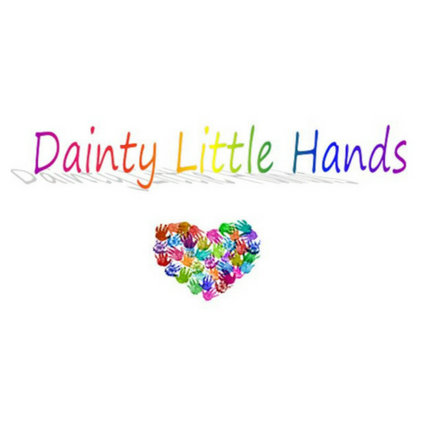

Intimate Care Policy
When providing intimate care we will ensure that the child’s safety, dignity and privacy are maintained at all times.
‘Intimate care’ covers any task that involves the washing, touching or carrying out a procedure to intimate personal areas and is associated with bodily functions and personal hygiene, including, toileting, washing, dressing, and menstrual care.
Staff at Dainty Little Hands LTD who provide intimate care will do so in a professional manner. Staff are aware of safeguarding issues and will have relevant training (eg: health and safety, child protection, manual handling) before providing intimate care. No child should suffer distress or pain as a result of receiving intimate care.
Staff will work in partnership with parents or carers to provide care appropriate to the needs of the individual child and together will produce a care plan. The care plan will set out:
- What care is required
- Number of staff needed to carry out the task (if more than one person is required, reasons will be documented)
- Additional equipment required
- Child’s preferred means of communication (eg verbal, visual)
- Child’s level of ability – what tasks they are able to carry out by themselves

Best practice
When intimate care is given, the member of staff will explain to the child each task that is carried out, and the reasons for it. Staff will encourage children to do as much for themselves as they can.
If a child requires intimate care on a regular basis, it is good practice for two members of staff to share the care between them. In this way the child is less likely to become overly dependent on a single member of staff, and to become distressed if their usual carer is occasionally unavailable. However, parents’ views on the number of staff providing personal care to their child must also be taken into consideration - some children may simply be unable to cope with more than one carer.
We have policies in place that promote safe recruitment, as well as having sound staff supervision, safeguarding and intimate care procedures; together these ensure that, should a child need consistent care from one member of staff, the child’s safety and wellbeing will not be compromised.

Protecting children
Staff are familiar with guidance from the Local Safeguarding Children Board. The Club’s procedures reflect the guidance in Working Together to Safeguard Children (2015) and staff are familiar with the What To Do If You’re Worried A Child Is Being Abused flowchart from this document.
If a member of staff is concerned about any physical changes to a child, such as marks, bruises, soreness etc, they will inform the manager or the Club’s designated child protection officer immediately. The procedures set out in the Safeguarding Children policy will be implemented.
Should a child become unhappy about being cared for by a particular member of staff, the Club manager or support manager will investigate and record any findings. These will be discussed with the child’s parents or carers22 in order to resolve the issue. If necessary, the manager will seek advice from outside agencies.
If a child makes an allegation against a member of staff, the procedure set out in the Safeguarding Children policy will be followed.

Dealing with blood and body fluids
Blood, vomit, urine and faeces will be cleaned up immediately and disposed of safely by double bagging the waste and removing it from the premises. When they are dealing with body fluids, staff will wear personal protective clothing (disposable plastic gloves and aprons) and will wash themselves thoroughly afterwards. Soiled children’s clothing will be bagged to go home – staff will not rinse it. Children will be kept away from the affected area until the incident has been dealt with fully.
Staff at Dainty Little Hands LTD maintain high standards of personal hygiene, and will take all practicable steps to prevent and control the spread of infection.

This policy was adopted by: Dainty Little Hands Ltd | Date: 31/07/2020
To be reviewed: 30/07/2020 | Signed: Jayne Dainty

Written in accordance with the Statutory Framework for the Early Years Foundation Stage (2017): Safeguarding and Welfare Requirements: Special educational needs [3.67], Child protection [3.6]and Suitable people [3.9-3.13].

