Dainty Little
Hands

Child Protection and Safeguarding Children Policy – Woodthorpe Infant and Junior School

Policy Statement
Everyone employed by the provision has a responsibility in relation to child protection and safeguarding children. In most cases this will be the referral of concerns to his/her line manager. In day-to-day contact with children and families – and particularly children identified as being at risk, staff have an opportunity to note concerns and to meet with parents and other associated adults.
This policy aims to outline the role that the provision will have in relation to child protection, the procedures that staff should take and guidance on issues related to child protection generally. It is not exhaustive. All staff should use as a rule the needs and safety of the child as being at the centre of any decision they make.
Dainty Little Hands Ltd will fulfil their local and national responsibilities as laid out in the following documents: -

- The most recent version of Working Together to Safeguard Children (DfE)
- The most recent version of Keeping Children Safe in Education:
Statutory guidance for schools and colleges (DfE Sept 2016)
- West Midlands Safeguarding Children Procedures
- The Education Act 2002 s175
- Mental Health and Behaviour in Schools: Departmental Advice (DfE 2014)

All staff should be aware of the guidance issued by Birmingham Safeguarding Children Partnership in Right Help Right Time, and Early Help.

The Aims of the Policy
The aims of this policy are:
- to raise awareness of individual responsibilities in identifying and reporting possible cases of abuse
- to provide a systematic means of monitoring, recording, and reporting of concerns and cases
- to provide guidance on recognising and dealing with suspected child abuse
- to provide a framework for inter-agency communication and effective liaison
- to identify strategies and interventions available to support children at risk.

Procedure
In order to safeguard children we will:
- adopt child protection guidelines as recommended by our Local Authority’s Safeguarding Children Board/Trust/Partnership and other appropriate professional bodies
- follow the Child Protection and Safeguarding Policy of the school
- implement appropriate procedures and code of conduct for the practice team
- raise awareness with staff that concerns about the welfare of a child and child protection will be taken seriously, with appropriate action being taken
- create an environment where children are listened to and their concerns taken seriously
- share information with other agencies on a need-to-know basis
- involve parents and children, except where doing so would put the child at greater risk of harm
- follow safer recruitment guidance and procedures
- provide effective staff management through access to supervision, support and training
- review this policy annually to ensure it is updated and informs day-to-day practice.

Designated Safeguarding Lead
The designated Safeguarding Lead (DSL) is Jayne Dainty. Their role is to help co-ordinate any concerns that are raised regarding the welfare of a child and to liaise with other professionals where appropriate, including the local authority social care for children. Her number is 07843391751 if you need to call her for any advice.
The designated person will:
- co-ordinate action within the provision and liaise with the Host School and social care services and other agencies over cases of abuse and suspected abuse
- act as a source of advice within the provision
- ensure that staff are familiar with the provision's policy and procedure
- make child protection referrals, recording and reporting accordingly
- liaise with agencies about individual cases
- organise training on child protection and safeguarding children within provision
- ensure that appropriate strategies for recording and reporting incidents are kept within provision
- provide appropriate feedback to members of staff as and when necessary.

Staff
Staff should:
- be alert to the signs of abuse as detailed in this policy
- report any concerns immediately, where possible to the designated person
- consult with the designated person if in any doubt as to how to proceed
- follow the advice given in this policy in relation to how to handle disclosures.

Partnerships with Parents
It is important that the provision has an established approach to working with parents. Parents' and children's need for privacy should be respected. However, the priority is the needs of the child and effective liaison is crucial for this.
It should be recognised that families from different backgrounds and cultures may have different approaches to raising children. These differences should be acknowledged and respected provided they do not place the child at risk as defined later in this policy.
Where possible staff should work with and share information with parents. Permission for liaison and information sharing with outside agencies should be sought unless it places the child at risk. In these cases, it is preferable to seek advice from social care services or make a child protection referral. Please see page 11 on how to do this.

Guidance on Recognising Abuse
Child abuse is a term used to describe ways in which children are harmed by someone often in a position of power. It is not the responsibility of staff to decide whether child abuse is occurring but to act on any concerns and report these to the appropriate party. The health, safety and protection of a child are paramount.
Abuse might fall into the categories of:
- physical
- emotional
- sexual
- neglect.
Staff should respond appropriately to signs and symptoms in a child which gives them cause for concern. These include but are not exhaustive:
- significant changes in children's behaviour or appearance
- frequent mood changes
- deterioration in their general well-being
- unexplained bruising, marks or signs of possible abuse
- signs of neglect such as being unkempt
- comments children make which give cause for concern
- not wanting to go home
- displaying sexualised behaviour
- a child who is quiet and withdrawn
- a child who gives the impression of being unloved and unhappy.
More details on how to recognise signs of abuse are available on https://www.nspcc.org.uk/preventing-abuse/signs-symptoms-effects
FGM
Female genital mutilation (FGM) is the partial or total removal of external female genitalia for non-medical reasons. It's also known as female circumcision or cutting.
Religious, social or cultural reasons are sometimes given for FGM. However, FGM is child abuse. It's dangerous and a criminal offence.
A girl at immediate risk of FGM may not know what's going to happen. But she might talk about or you may become aware of:
- a long holiday abroad or going 'home' to visit family
- relative or cutter visiting from abroad
- a special occasion or ceremony to 'become a woman' or get ready for marriage
- a female relative being cut – a sister, cousin, or an older female relative such as a mother or aunt.
More details on how to recognise signs of abuse are available on https://www.nspcc.org.uk/preventing-abuse/child-abuse-and-neglect/female-genital-mutilation-fgm/preventing-protecting/
RADICALISATION AND EXTREMISM
Radicalisation happens when a person's thinking and behaviour become significantly different from how most of the members of their society and community view social issues and participate politically. Only small numbers of people radicalise and they can be from a diverse range of ethnic, national, political and religious groups.
As a person radicalises they may begin to seek to change significantly the nature of society and government. However, if someone decides that using fear, terror or violence is justified to achieve ideological, political or social change—this is violent extremism.
Radicalisation can be really difficult to spot. Signs that may indicate a child is being radicalised include:
- isolating themselves from family and friends
- talking as if from a scripted speech
- unwillingness or inability to discuss their views
- a sudden disrespectful attitude towards others
- increased levels of anger
- increased secretiveness, especially around internet use.

Children who are at risk of radicalisation may have low self-esteem, or be victims of bullying or discrimination. Extremists might target them and tell them they can be part of something special, later brainwashing them into cutting themselves off from their friends and family.
CSE
Child sexual exploitation (CSE) is a type of sexual abuse. Children in exploitative situations and relationships receive something such as gifts, money or affection as a result of performing sexual activities or others performing sexual activities on them.
Children or young people may be tricked into believing they're in a loving, consensual relationship. They might be invited to parties and given drugs and alcohol. They may also be groomed and exploited online.
Some children and young people are trafficked into or within the UK for the purpose of sexual exploitation. Sexual exploitation can also happen to young people in gangs.
Child sexual exploitation is a hidden crime. Young people often trust their abuser and don't understand that they're being abused. They may depend on their abuser or be too scared to tell anyone what's happening.
It can involve violent, humiliating and degrading sexual assaults, including oral and anal rape. In some cases, young people are persuaded or forced into exchanging sexual activity for money, drugs, gifts, affection or status. Child sexual exploitation doesn't always involve physical contact and can happen online.
When sexual exploitation happens online, young people may be persuaded, or forced, to:
- send or post sexually explicit images of themselves
- take part in sexual activities via a webcam or smartphone
- have sexual conversations by text or online.
Abusers may threaten to send images, video or copies of conversations to the young person's friends and family unless they take part in other sexual activity.
Images or videos may continue to be shared long after the sexual abuse has stopped.

Sexual exploitation can be very difficult to identify. Warning signs can easily be mistaken for 'normal' teenage behaviour.
Young people who are being sexually exploited may:
- go missing from home, care or education.
- be involved in abusive relationships, intimidated and fearful of certain people or situations
- hang out with groups of older people, or antisocial groups, or with other vulnerable peers
- associate with other young people involved in sexual exploitation
- get involved in gangs, gang fights, gang membership
- have older boyfriends or girlfriends
- spend time at places of concern, such as hotels or known brothels
- not know where they are, because they have been moved around the country
- be involved in petty crime such as shoplifting
- have unexplained physical injuries
- have a changed physical appearance, for example lost weight.
More details on how to recognise signs of abuse are available on
https://www.nspcc.org.uk/preventing-abuse/child-abuse-and-neglect/child-sexual-exploitation/

Policy on Dealing with Suspected Abuse
All staff should refer concerns to the designated person as soon as possible. However if you believe a child is in immediate danger, contact the Police immediately.
THE DESIGNATED PERSON FOR ALL DAINTY LITTLE HANDS SETTINGS IS JAYNE DAINTY – 01922682232/07843391751
In the meantime, they should:
- consider the child’s welfare as paramount
- believe the child and take them seriously
- remain calm and caring
- reassure the child that they have done the right thing in talking to them
- make notes of the conversation as soon as possible, using the child's own words
- explain to the child what will happen next and who will be told

STAFF SHOULD NOT:
- promise confidentiality
- postpone the discussion until a different time
- interpret what they have been told
- ask leading questions.
IF IN DOUBT, CONTACT THE POLICE IMMEDIATELY

Where the staff member suspects that a child is being abused they should:
- immediately tell the designated safeguarding lead for safeguarding and child protection about their concerns
- make factual notes of what has occurred, using the child's own words where relevant, and any action taken.
The designated safeguarding lead will follow the procedure below.
- Where possible, they will calmly discuss the concerns with the child and their parents and obtain agreement to making a referral to children social care services unless this discussion will put the child in increased risk of harm. Under no circumstances continue the discussion if it becomes confrontational. If a child’s disclosure is about significant abuse from their parent under no circumstances confront the parent of the alleged abuse as there is a risk of compromising any investigation or prosecution.
- Seek professional advice from Children Care Services if unsure about whether or not to talk to parents first.
- If the perpetrator of the alleged abuse is not a parent of the child/children under no circumstances confront them.
- When a referral is made, agree what the child and parents will be told, by whom and when. Inform the recipient of the referral what information has already been discussed with the child and their parents.
- If a telephone referral is made it must be confirmed in writing within 48 hours. Children's social care services should acknowledge the written referral within one working day of receiving it, indicating the course of action chosen. If nothing has been heard back within three working days, contact children's social care again.

Confidentiality
Relevant information about the protection of children must be shared with the investigative agencies, but only on a “need to know” basis.
Staff should be careful in subsequent discussions and ensure that information is only given to the appropriate person. All staff should be kept aware of issues relating to confidentiality and the status of information they may hold.

The Use of Mobile Telephones and Digital Cameras Policy
This organisation believes that mobile telephones used in the correct and safe manner can have a positive benefit to the operation of the organisation and to the health and safety of its employees. Use of mobile telephones in the wrong place, at the wrong time or in the wrong circumstances can cause accidents and interrupt activities to the detriment of the organisation, employees and others.
The organisation will allow the sensible use of mobile telephones, provided by the organisation, provided the basic health and safety rules and sensible use are followed.
NO SMART PHONES OR DIGITAL CAMERAS ARE TO BE USED AT ANY TIME WITHIN TIMES THAT CARE IS PROVIDED.
All personal mobile phones should be locked in the cabinet before school club opens.

Procedure
- Employees must keep the use of mobile telephones to a minimum, ie few calls and of short duration.
- The Company will provide a basic mobile phone handset to be used in club.
- The Company will provide a Instant (Polaroid) Cameras for use in club.
- All Smart phones or digital cameras are to be locked away in the filing cabinet provided and are not to be used in any circumstance.
- All visitors must also lock away their phones on entering the club.
- Employees should avoid pressing the mobile telephone tight against the ear. They should try to hold it away from the side of the head, and alternate between left and right ear.
- If employees have a cardiac pacemaker or other medically implanted device, they should seek medical advice before using a mobile telephone.
- Employees must not make or answer calls whilst driving a car on company business and MUST exercise proper control of their vehicle at all times.
- Employees should consider the use of a hands-free set incorporating earpiece and microphone in vehicles. Otherwise they should turn off the mobile telephone whilst driving or switch it to messaging.
- Employees must never use a hand-held mobile telephone or microphone when driving. They should find a safe place to stop before answering or making a call.
- Employees should remember that using “hands-free” equipment is also likely to distract them while driving. They should find a safe place to stop before answering or making a call.
- Employees MUST NOT stop on the hard shoulder of a motorway to answer or make a call, except in an emergency.
- Employees should switch off their mobile telephone when at a petrol refuelling station or when near any other potentially flammable atmosphere.
- Employees should switch off their mobile telephone when visiting a hospital ward or inside an aircraft.
Parents, Carers and Visitors are NOT permitted to use their phones in school club.
E Safety and Online Gaming
No member of staff is permitted to enter into any conversation regarding personal on-line gaming habits or internet use. It is prohibited to share any social media contact information, on line gaming contact details or any other information relating to contacting children out side of school and club settings.

Signed: | ______Jayne Dainty_______________________
Date: | ________10/08/2020_____________________
Policy review date: | _________09/08/2021____________________

FOR WOODTHORPE SCHOOL (Birmingham Safeguarding Children Partnership)

If you have any concerns about the safety and/or welfare of a child or young person telephone the Children's Advice & Support Service (CASS) on 0121 303 1888 or via secure email; CASS@birminghamchildrenstrust.co.uk.
Outside of normal office hours please call 0121 675 4806 for the Emergency Duty Team
For more information about making a referral and to access the Request for Support form
Birmingham Safeguarding Children Partnership that replaces the Local Safeguarding Children Board launched on the 1st April 2019.
The Children and Social Work Act 2017 defines three ‘Safeguarding Partners’ to oversee and lead the arrangement to safeguard and promote the welfare of children. In Birmingham, the Local Authority, Birmingham and Solihull Clinical Commissioning Group and West Midlands Police will share equal responsibility for developing and leading the new partnership arrangements.
The new partnership builds on the strong foundation and substantial improvements made by the Local Safeguarding Children Board, to have a common purpose and agreed behavioural values to reinforce shared priorities set out in our Business Improvement Plan 2019/21.
We recognise that to be strong and effective, the Partnership must engage the right people. We have worked collaboratively with a wide range of partners across the city to identify the organisations and agencies which need to be involved to safeguard and promote the welfare of Birmingham’s children.
We view ‘partnership’ as a verb and agencies will be expected to work together to share and co-own the vision of how to achieve improved outcomes for vulnerable children and young people in Birmingham. Birmingham Safeguarding Children Partnership will promote appropriate support and challenge between partners, ensuring that leaders and staff within every organisation are held to account. We will also create the conditions to develop a transparent learning culture, driving best collaborative practice for good and outstanding outcomes for children and young people.
All our work will be underpinned by a consideration of the views and experiences of Birmingham’s children and young people. We acknowledge that the new arrangements will only be effective if they make a difference to the wellbeing of Birmingham’s children and young people and ask for help from professional partners and citizens of Birmingham in making this a reality.

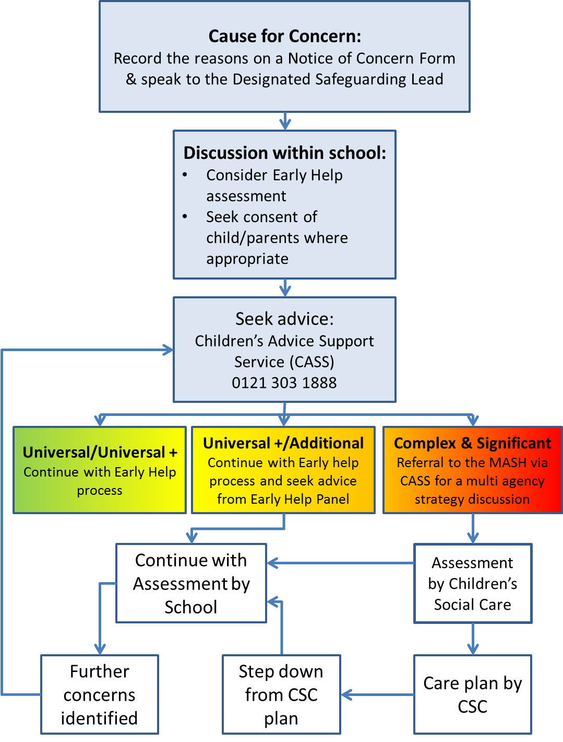

We work in partnership with other agencies to promote the best interests of our children as a top priority in all decisions and actions that affect them. Dainty Little Hands will, where necessary, liaise with these agencies and make requests for support from children’s social care. These requests will be made by the Designated Safeguarding Lead to the Children’s Advice Support Service (CASS) - 0121 303 1888. Where the child already has a safeguarding social worker or family support worker, the request for support should go immediately to the team involved, or in their absence to their team manager.

When invited the DSL will participate in a MASH strategy meeting, usually by conference phone, adding school held data and intelligence to the discussion so that the best interests of the child are met.

We will co-operate with any child protection enquiries conducted by children’s social care: the school will ensure representation at appropriate inter-agency meetings such as integrated support plan meetings initial and review child protection conferences, and core group meetings.

We will provide reports as required for these meetings. If the school is unable to attend, a written report will be sent. The report will, wherever possible, be shared by Social Care with parents / carers at least 24 hours prior to the meeting.

Where a student is subject to an inter-agency child protection plan or a multiagency risk assessment conference (MARAC) meeting, the school will contribute to the preparation, implementation and review of the plan as appropriate.

RESPONDING TO AN ALLEGATION ABOUT A MEMBER OF STAFF

Allegations or concerns about staff, colleagues and visitors must be reported directly to the DSL Jayne Dainty who will liaise with the Birmingham Children’s Trust Designated Officer (LADO) Team who will decide on any action required.

If the concern relates to Jayne Dainty, it must be reported immediately to the Birmingham Children’s Trust Designated Officer (LADO) Team who will decide on any action required.

The LADO Team can be contacted on 0121 675 1669 or via email: Ladoteam@birminghamchildrenstrust.co.uk.

The LADO Team can be contacted on 0121 675 1669 or if you have access to secure email: Lado.secure@birmingham.gcsx.gov.uk. If you do not have access to secure email: Ladoteam@birminghamchildrenstrust.co.uk.

